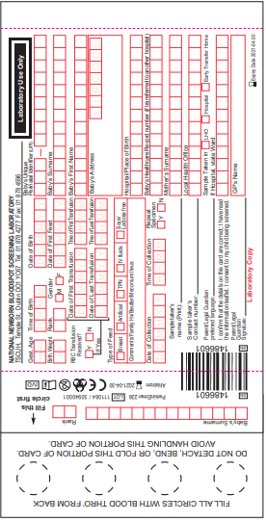

Circles need to be soaked through to the back with blood

This is very important in diagnosing inborn errors of metabolism

Each maternity hospital has their own number. This is found on the lid of our Newborn Screen box

This is the baby’s hospital number from the maternity hospital.

The infant may be on more than one form of feeding

If it is a single baby – 1/1

If it is twin 1 – 1/2

Twin 2- 2/2 etc.

Please check at the back to see which circle to fill first

Don’t forget to get parent’s consent and note their preferred language